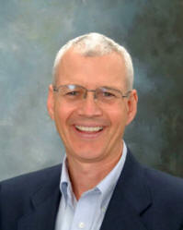

Steven L. Anderson, Ph.D., MBA
President and Senior Consultant
Integrated Leadership Systems, LLC

Dr. Anderson received his Bachelor of Science in agriculture from The Ohio State University in 1980. From 1980 until 1994 he held several management positions in the agriculture and retail industries. During this time, he obtained his Master’s in Business Administration from Capital University in Columbus, Ohio. In 1999 he obtained a Ph.D. in psychology at The Ohio State University.

Since 2001 Dr. Anderson has run his growing company, Integrated Leadership Systems, which does leadership training, executive coaching, and consulting. ILS is based in Columbus, Ohio and provides services for hundreds of companies all over North America. ILS has done consulting for many nationally recognized companies including Honda, Nationwide, Husky Energy, Ohio State University, OhioHealth, Elmer’s Products, Kokosing Construction and Worthington Industries.
Dr. Steven Anderson is the Author of the books, “The Call to Authenticity”, “Embracing Rebellion”, “How to Create a World Class Company”, and “Success Strategies.”

